Central America
Belize
Guatemala
El Salvador
Honduras
Nicaragua
Costa Rica
Panama

North America
Canada
Greenland
United States
Bermuda
Clipperton Island
Mexico
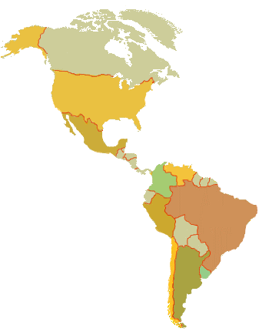
Saint Pierre and Miquelon

]

South America
Argentina
Bolivia
Brazil
Chile
Columbia
Ecuador
Falkland Islands ^{(Islas Malvinas)}
French Guiana ^{(France)}
Guyana
Paraguay
Peru
South Georgia and South Sandwich Island
Suriname
Uruguay
Venezuela


