SEMESTER I EXAM REVIEW
INTRODUCTION
- List and describe the properties of life.
- List and explain the steps in the scientific process.

STATISTICAL ANALYSIS
- Study Statistics study guide then go over the following to check yourself.
- What is meant by the following terms?
  - Mean
  - Standard deviation,
  - Range/variablility
- What are error bars use for?
- in which two pairs of groups below can we see an overlap in the standard deviation of data?
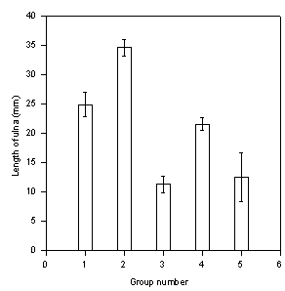

- ______ and ______

- ______and _______

- In which group is the mean NOT likely to be significantly different
to the mean of group 3? Why?

- What is quanitative data?
- What is qualitative data?
- What is meant by uncertaintly
- What is statistics?
- What is a collation?
- State whether the following are correlated or causal relationships.
  - The more light the more photosynthesis in the plants.
  - SAT scores and higher achievement
  - The less oxygen to a cell the less cell respiration.
  - Years in prison and education
BIOCHEMISTRY

- Study the Biochemistry study guides (2 of them) then check yourself.
- Atoms are composed of
- Protons, electrons and neutrons have a charge of
- Element is
- Matter is compose of
- Polar molecules are
- Ionic bonds form when
- Covalent bonds form when
- Water is a polar molecule because
- Organic molecules are
- Organic molecules can be classified into four main types. What are they?
- Polysaccharides are
- Amino acids are found in
- Examples of lipids are
- Identify the following:
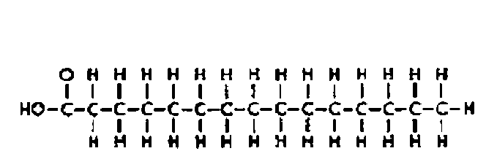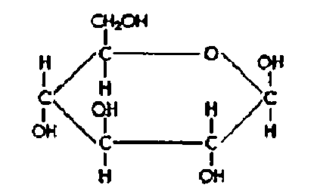

- Animal store glucose in the form of
- Two types of nucleic acids are
- Hydrogen bonding is
- Cohesion occurs because
- State the effects that occur for each of the following statements.
  - Organisms resist temperature changes, although they give off heat due to chemical reactions.
  - A water strider can walk across the surface of a small pond.
  - Lakes don’t freeze solid in winter, despite low temperatures.
  - The pH of water remains exactly neutral.
  - Water can mix with other substances easily.
- Why does ice float in liquid water?
- Summarize dehydration reactions.
- Summarize hydrolysis reactions.
- What is a monosaccharide, disaccharide and polysaccharide and give examples?
- What is a lipid and give examples?
- What is the difference between a saturated and unsaturated fat?
- Are lipids soluble in water?
- What is a triglyceride?
- Two amino acids bonded together form a ________________bond.
- Which four elements make up approximately 96% of living matter?
CELLS
- Study Cell study guides (2 of them) then check yourself.
- State the cell theory.
- How did the following influence the belief in the cell theory?
  - Hooke
  - Schleiden
  - Schawann
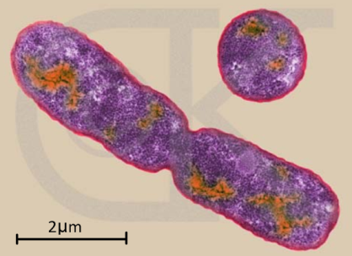
  - Pasteur
  - Light microscope
  - Electron microscope
  - Fleming
- What is the magnification of the image?
- State advantages of maximizing the surface area: volume ratio in a cell?
- Two things a large cell might do to increase its surface area: volume ratio is
- State the 6 functions of life.
- State the difference between eukaryote and prokaryote.
- What is an organelle?
- Identify the following structures and functions in an animal and plant cell.
  - Cell membrane (plasma membrane)
  - Cell wall
  - Nucleus
  - Chromosomes
  - Ribosomes
  - Golgi apparatus
  - Smooth and rough endoplasmic reticulum
  - Vacuole
  - Cytoplasm
  - Lysosomes
  - Chloroplasts
  - mitochondria
- Flagella are
- Cilia are
- Describe a phospholipid
- Distinguish between active transport and passive transport.
- Describe the types of passive transport.
  - Diffusion
  - Facilitated diffusion
  - Osmosis-
  - Understand what happens when a cell is placed in a hypertonic, hypotonic and isotonic solution.
- Describe the types of active transport.
  - Bulk transport
    - Endocytosis
    - Exocytosis
      - Pinocytosis
      - Phagocytosis
- What is a concentration gradient?
- Describe the sodium-potassium pump.
CELL DIVISION
- Study the Cell division study guide and worksheets then check yourself.
- Describe the phases of mitosis –include interphase and cytokinesis.
- Identify a sketch of the phases of mitosis.
  - How many cells at the end of mitosis? How many chromosomes in those cells?
  - What are the cell called at the end of mitosis?
  - What happens after mitosis?
- Describe the phase of meiosis.
- Identify a sketch of the phases of meiosis.
  - How do Homologous chromosome appear at each phase in meiosis I
  - How do the chromosomes appear at each phase in meiosis II.
  - Synapsis is
  - Crossover is
  - How many cells at the end of meiosis. How many chromosomes in those cells.
  - What are the cells called at the end of meiosis?
  - What happens after meiosis?
- Describe the cell cycle.
- Cancer is
- Describe the types of cancer.
- Stem cells are
- Types of stem cells are
- Stem cells are used for

